# Understanding the Sliding Window Technique in Programming

The sliding window is a powerful algorithmic technique used to solve a variety of problems that involve linear data structures like arrays or strings. It helps reduce the time complexity by avoiding redundant computations and often leads to elegant and efficient solutions.

## 1. Introduction

Many programming problems require processing consecutive elements in a dataset. The sliding window technique allows you to maintain a subset (“window”) of data that "slides" through the dataset. Instead of recalculating the entire sum or property of the window each time it moves, you update the answer incrementally by removing the contribution of the element that is left behind and adding the new element that comes into the window.

## 2. What is a Sliding Window?

A sliding window is a subset of sequential data of fixed or variable size that moves over the dataset. At each step:

* **Enter:** A new element is added to the window.
* **Exit:** The oldest element is removed from the window.

This approach is extremely useful for problems like:

* **Maximum/Minimum Sum Subarray:** Finding the subarray of a fixed size that has the highest (or lowest) sum.
* **Substring Problems:** Identifying the longest substring with unique characters, or the substring that meets certain criteria.
* **Real-Time Data Processing:** Managing a stream of data, such as calculating the moving average over time.

## 3. How the Sliding Window Technique Works

### Conceptual Overview

The goal is to find the maximum sum of any subarray of size k = 3. Instead of computing the sum of every possible subarray from scratch, you can:

1. **Initialize the Window:** Calculate the sum of the first k elements.
2. **Slide the Window:** For each new window position, subtract the element that is left behind and add the next element in the sequence.
3. **Update the Answer:** Keep track of the maximum (or required) value found.

**Visual Diagram**

*T*he efficiency of the technique lies in its ability to update results incrementally as the window moves rather than re-iterating over every element of each subarray. In the example provided, the sum is updated with just two operations (subtract and add) rather than summing over the entire window each time.

## 4. Code Examples

### Example 1: Maximum Sum Subarray

Python example using sliding window technique to find the max sum of a subarray of size k:

1. def max_sum_subarray(arr, k):

2. n = len(arr)

3. if n < k:

4. return None

5.

6. # Compute the sum of the first window

7. current_sum = sum(arr[:k])

8. max_sum = current_sum

9.

10. # Slide the window from start to end of the array

11. for i in range(k, n):

12. current_sum = current_sum - arr[i - k] + arr[i]

13. max_sum = max(max_sum, current_sum)

14.

15. return max_sum

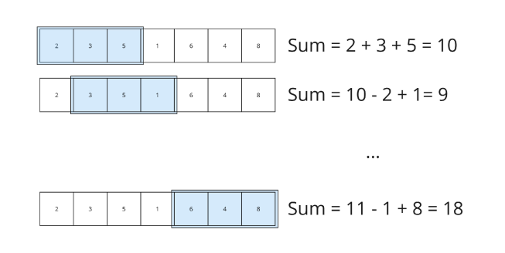

### Example 2: Finding a Substring with Unique Characters

A sliding window can also solve problems related to strings. Here is an example finding the length of the longest substring without repeating characters:

1. def longest_unique_substring(s):

2. char_set = set()

3. left = 0

4. max_length = 0

5.

6. for right in range(len(s)):

7. while s[right] in char_set:

8. char_set.remove(s[left])

9. left += 1

10. char_set.add(s[right])

11. max_length = max(max_length, right - left + 1)

12.

13. return max_length

**5. Applications of the Sliding Window Technique**

The sliding window technique is widely applicable in various fields:

* **Data Stream Processing:** Calculating moving averages or sums over real-time data.
* **Network Protocols:** Managing a window of packets in protocols like TCP to ensure reliable delivery.
* **Computer Vision:** Analysing a subset of an image (or video frame) for object detection.
* **Financial Analysis:** Evaluating the moving average of stock prices.

**6. Conclusion**

The sliding window technique is an efficient way to handle problems that involve contiguous sequences. Its ability to reuse previous computations rather than recalculating from scratch results in significant performance improvements, especially for large datasets. Whether working on algorithm challenges, real-time data processing, or even network protocols, mastering the sliding window approach can be a valuable addition to a programmer’s toolkit.